CHAPTER 3: Cells
Worksheet 3.2

In focus
Student: Class:

Microscope
In order to zoom in on the units of life, you first need to be able to focus. Add labels to the diagram below.
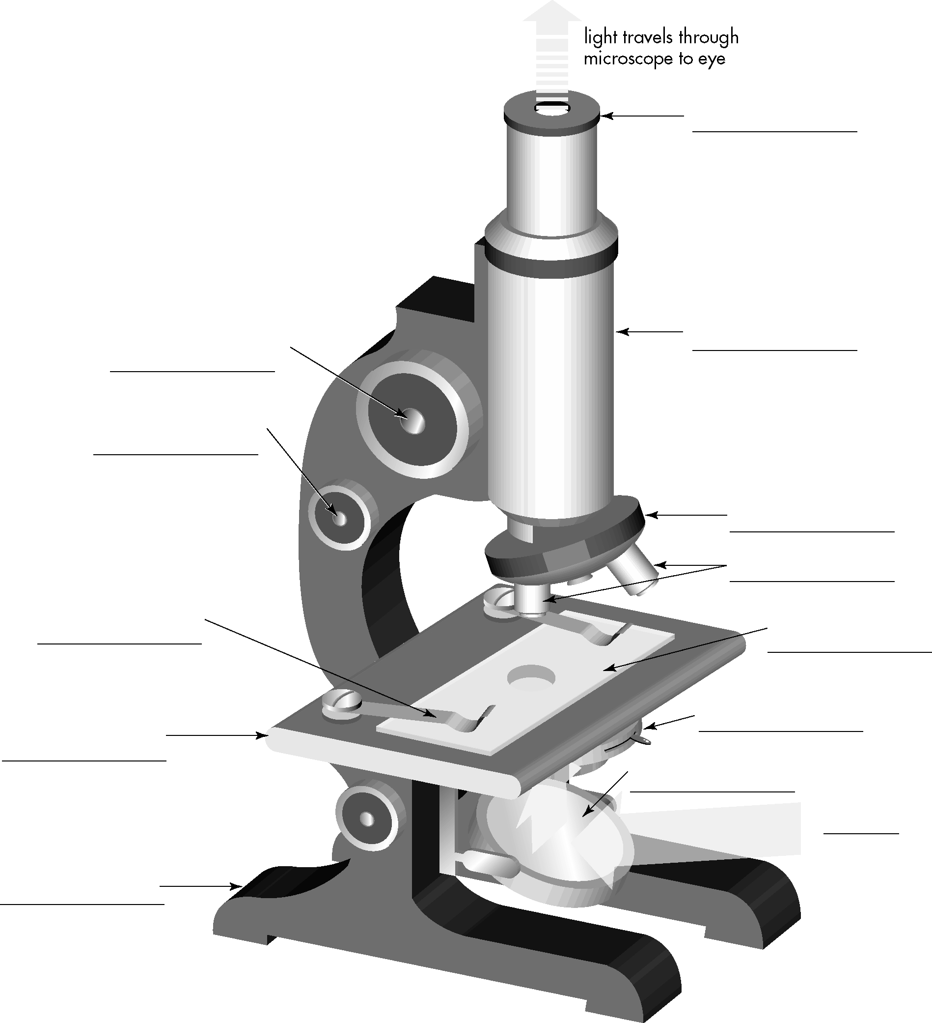
Important reminders when using a microscope
1. When lifting the microscope, put one hand on the body of the microscope and one hand under its .
2. The microscope should be used on a and not too close to the edge.
3. Take care that the intensity is not too high, or it might damage your eye.
4. Return the shortest lens into position when finished.
5. Remove the , and ensure that the stage is clean.
6. Make sure that, when your microscope is not in use, it is always clean and carefully put away.

